Week 1: This month’s wellbeing topic is healthy eating

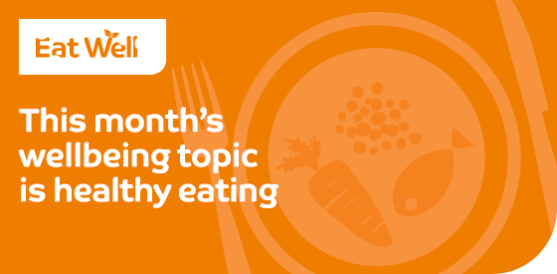

We could all probably benefit from eating a little bit healthier, but sometimes the messages in the media can be confusing. Check out this month’s information on the truth about superfoods, food intolerance and top tips for snacking at work.

Choosing healthier foods is easier than you think and most of us only need to make relatively small changes to the foods we eat each day. One of the easiest changes to make is to eat more fruit and vegetables each day.

Use this month’s information to help you identify and make those small changes to your diet – together they will add up to make a big overall difference to your health, vitality and your weight!

Check out:
Snacking at work – Factsheet >

Superfoods – Factsheet >

Food intolerance – Factsheet >

Top tips – Poster/Leaflet >

Further support – Poster/Leaflet >

Best wishes,

The Westfield Health Team

Week 2: Are you intolerant to certain foods?

A food intolerance refers to difficulty digesting certain foods and having an unpleasant physical reaction to them. Symptoms usually occur a few hours after consuming the food. (NHS)
Symptoms can include:
- Bloating
- Stomach pain
- Wind
- Diarrhoea
- Skin rashes and itching
If you experience any of these, contact your GP who will be able to discuss your symptoms and advise you correctly, as these are also symptoms of many other conditions.

Check out:
Snacking at work – Factsheet >

Superfoods – Factsheet >

Food intolerance – Factsheet >

Top tips – Poster/Leaflet >

Further support – Poster/Leaflet >

Best wishes,

The Westfield Health Team

Week 3: Sugar – are you consuming too much?
Regularly consuming foods and drinks high in sugar increases your risk of obesity and tooth decay.
Here are some simple goals for you to achieve this week:
- Limit packaged or processed foods, especially ready meals and fast foods
- Cut down on savoury and sweet spreads, such as ketchup, jam, etc.
- Avoid sugary soft drinks and sweetened fruit juices
- Reduce chocolate and cake intake

Check out:
Snacking at work – Factsheet >

Superfoods – Factsheet >

Food intolerance – Factsheet >

Top tips – Poster/Leaflet >

Further support – Poster/Leaflet >

Best wishes,

The Westfield Health Team

Week 4: Superfoods may not be as super as you think!

A ‘superfood’ is a marketing term used to describe foods with supposed health benefits. The European Union has banned health claims on packaging unless supported by scientific evidence.
Many dieticians and nutrition scientists dispute the fact that particular foods have ‘super health’ benefits and promote the concept of a Mediterranean style diet, rich in fruits and vegetables, rather than label individual foods as ‘super’.

Quite often, superfoods are only super when eaten in unrealistic quantities. For example, research has found that garlic contains a nutrient alleged to help reduce cholesterol and blood pressure. But you'd have to eat up to 28 cloves a day to match the doses used in the laboratory – something no researcher has yet been brave enough to try.

It is best not to concentrate on any one food, or food group, in the hope that it will work miracles. Instead opt for a healthy balanced diet, typically high in fruit, vegetables and whole grain foods and low in red meat.

Check out:
Snacking at work – Factsheet >

Superfoods – Factsheet >

Food intolerance – Factsheet >

Top tips – Poster/Leaflet >

Further support – Poster/Leaflet >

Best wishes,

The Westfield Health Team

